**Sin wave, frequency 60 Hz.**

**Phase Shift = 0**

**WaveForm:**

**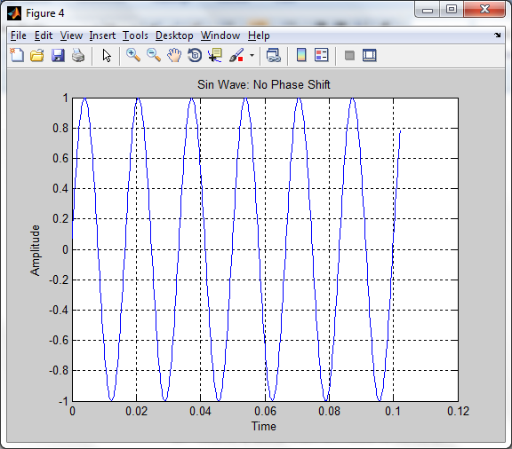**

**Normalized FFT**

**\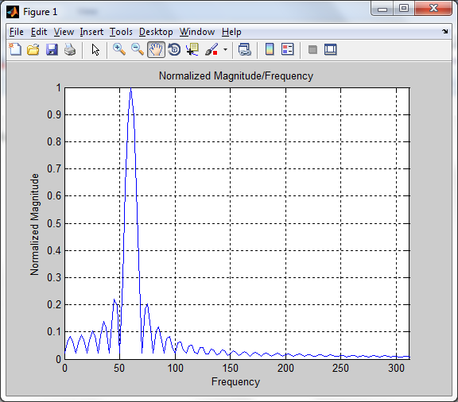**

**Real Frequency**

**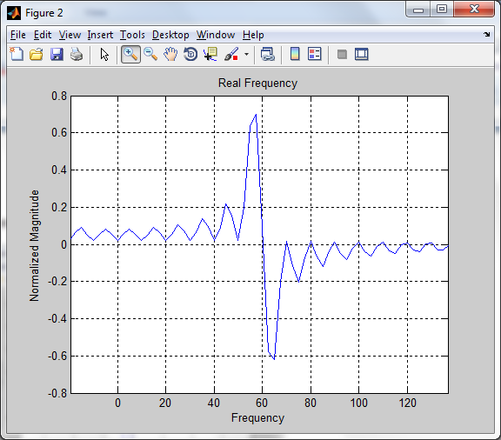**

**Imaginary**

**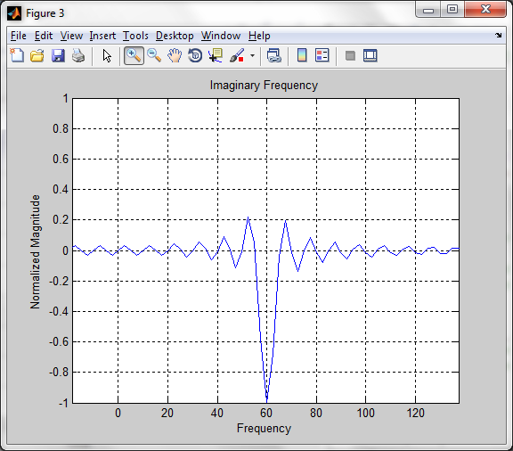**

**Sin wave, frequency 60 Hz.**

**Phase Shift = 180**

**Waveform**

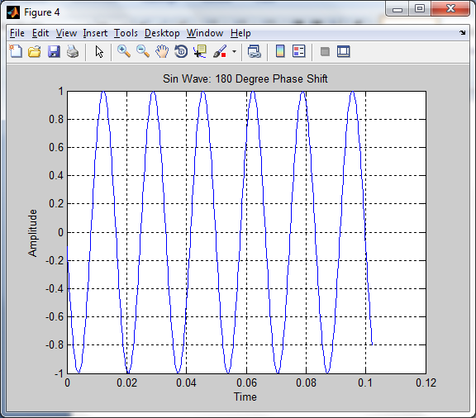

**Normalized FFT**

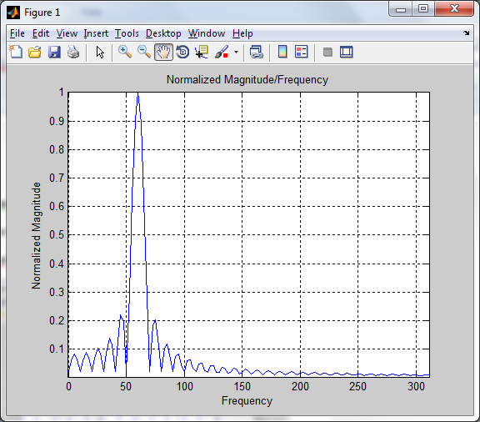

**Real FFT**

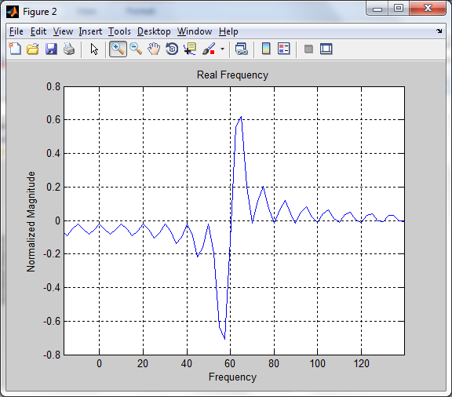

**Imaginary FFT**

**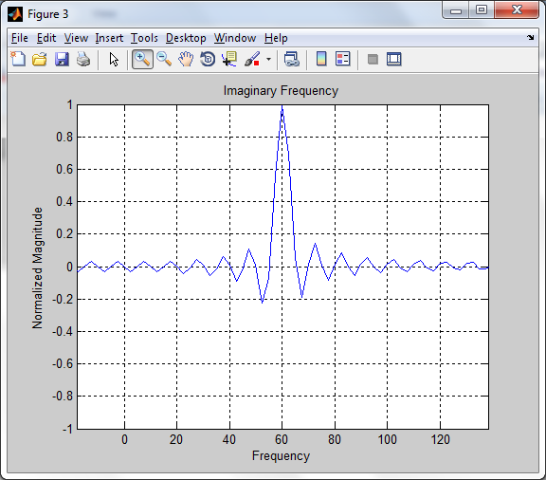**

**Sin wave, frequency 60 Hz.**

**Phase Shift = 90**

**Waveform**

**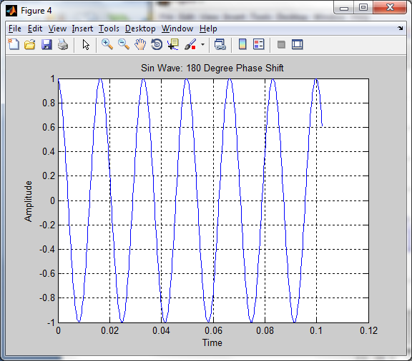**

**Normalized Frequency**

**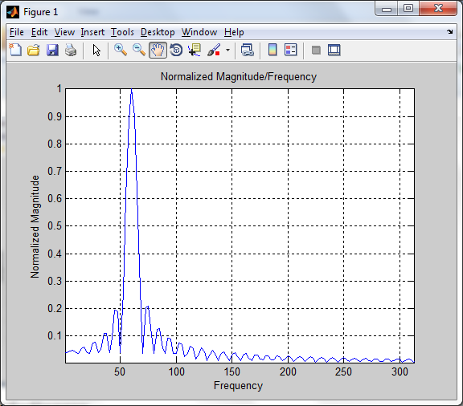**

**Real FFT**

**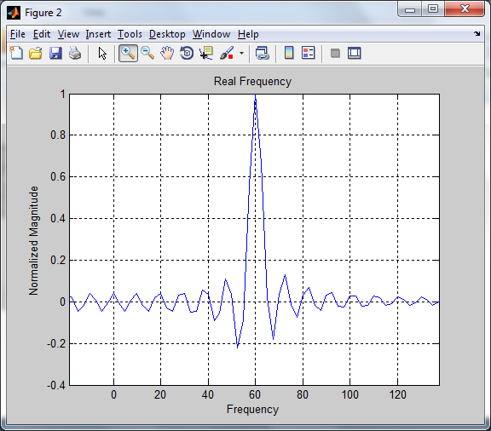**

**Imaginary FFT**

**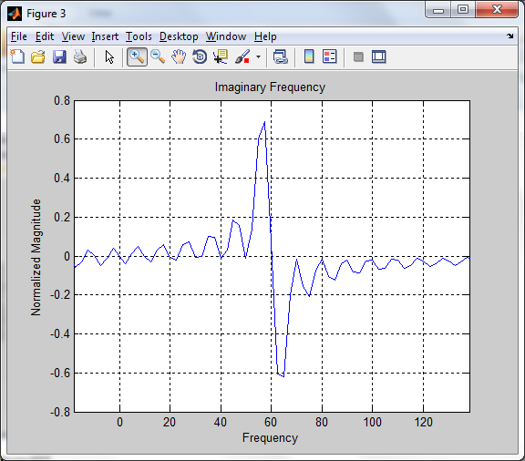**

**Sin wave, frequency 60 Hz.**

**Phase Shift = 270**

**Waveform**

**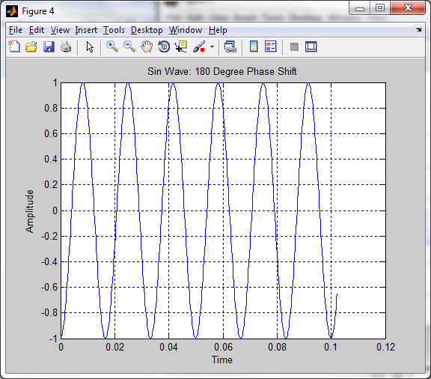**

**Normalized FFT**

**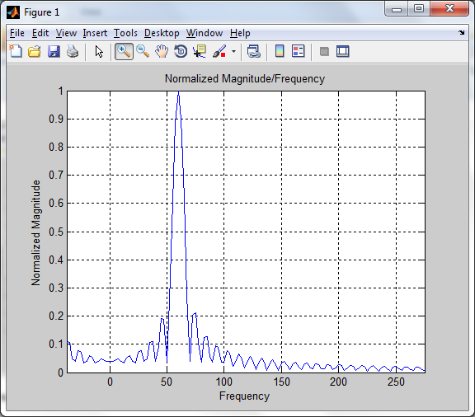**

**Real FFT**

**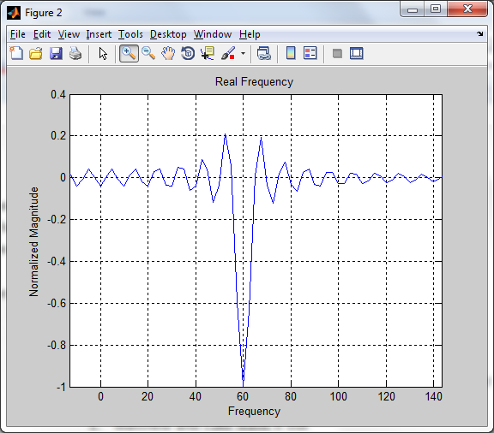**

**Imaginary FFT**

**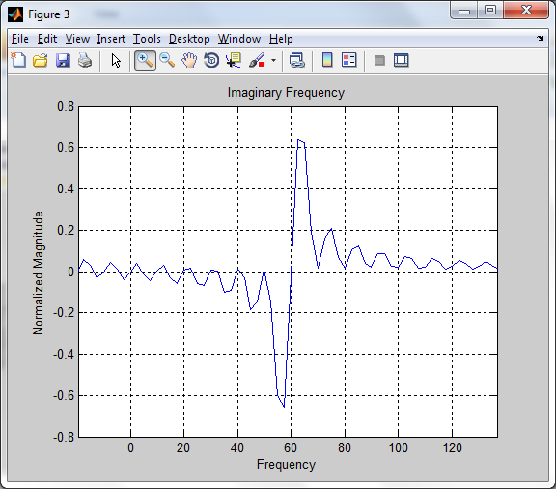**

**Why?**

**Fourier Transform:**

\hat{f}(\xi) = \int_{-\infty}^{\infty} f(x)\ e^{- 2\pi i x \xi}\,dx

**When we shift, Normalized values are the same ( $\sqrt{Re\left\{S(F)\right\}^2+ Im\{S(F)\}^2}$)**

**However, Real and Imaginary Components are different!!**

**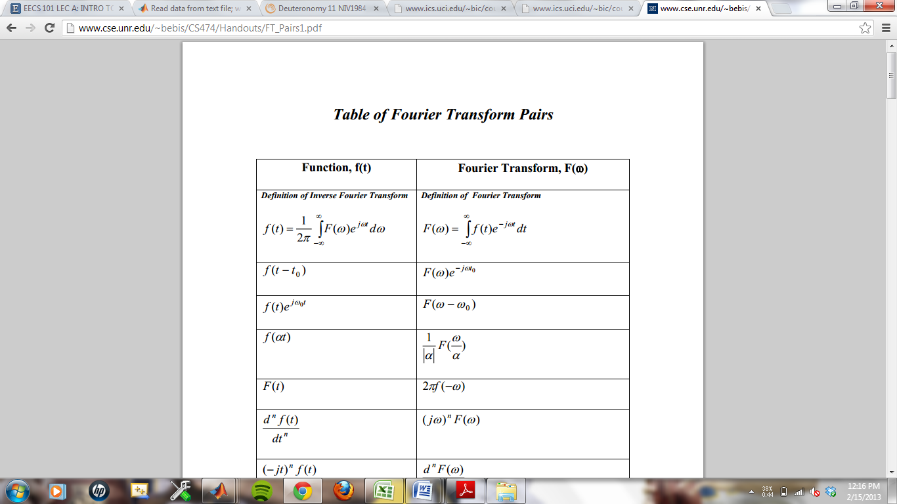**

**When we shift by 90, we multiply S(F) by ‘j’**

**s(t + π/2) = j\*S(F)**

**When we shift by 180, we multiply S(F) by ‘-1’**

**s(t + π) = -1\*S(F)**

**When we shift by 270, we multiply S(F) by ‘-j’**

**s(t + 3π/2) = -j\*S(F)**

**Our data is consistent when we shift our values by 360 degrees**

**Excel File**

**However, our phase sometimes changed “signs”. This is due to the fact that sometimes, the real or imaginary component of FFT is close to 0, and fluctuated signs. We find that Real and Imaginary FFT is more reliable.**

**Thus, when we find phase, it is important when we record the waveform, to always start on the same starting point. In our case, we wish to always start recording at the local maximums**

